Case Study (Hypothetical)
Persistent Oxygen-indUced Tachycardia with Neonatal onsEt (POUTINE), is a life-threatening illness with highest prevalence in Canada and North-Eastern United States, first diagnosed in 1957 in Fernand Lachance of Warick, Quebec.. In 2010, a meta-analysis combining the results of three pivotal trials established the efficacy of a surgical treatment for neonates diagnosed with POUTINE was published in JAMA. Authors reported a clinically meaningful but not statistically significant increase in severe Sepsis

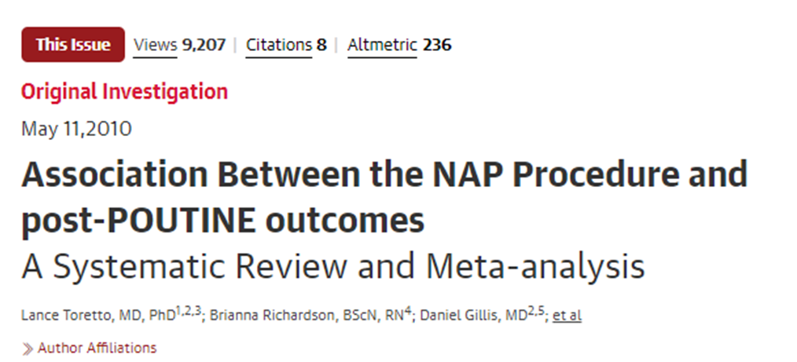

Since 2010 NAP has become standard care in many hospitals. Four recent non-randomized studies have suggested the sepsis risk may be more serious than originally thought Your hospital has asked you to provide an updated meta-analysis combining the original RCTs with new randomized studies to assess whether the sepsis risk is a concern

Exercise:

You have been provided with the following files:

1. smdm_obs_rct.xlsx: An excel workbook containing data from RCTs and Observational trials
2. smdm_obs_rct.R: An R script set up to run the necessary analyses
3. A base JAGS model for the multilevel case which you will edit

